

Agent

Observation of state $S$

Reward $R$

Action $A$



Environment

Initialize Q-value table and hyper-parameters

Present sound $a_{t}$ to user and probe user for feedback $\hat{S}$ and $C$

Calculate uncertainty $U_{t}\left(a\right)$ for each action

Select sound $a_{t}$ using $\underset{a A}{arg max}\left(Q_{t}\left(a\right)+U_{t}\left(a\right)\right)$

Terminate

Calculate change in $Q$

$$∆Q=Q_{t+1}\left(a\right) {- Q}_{t}(a)$$

Calculate reward $R$ andupdate Q-value table with $Q_{t+1}\left(a\right)$

Increment budget $B$

Increment timestep $t$

NO

YES

Remaining budget $B$?

Converged?

NO

YES

Check for convergence using $∆Q$

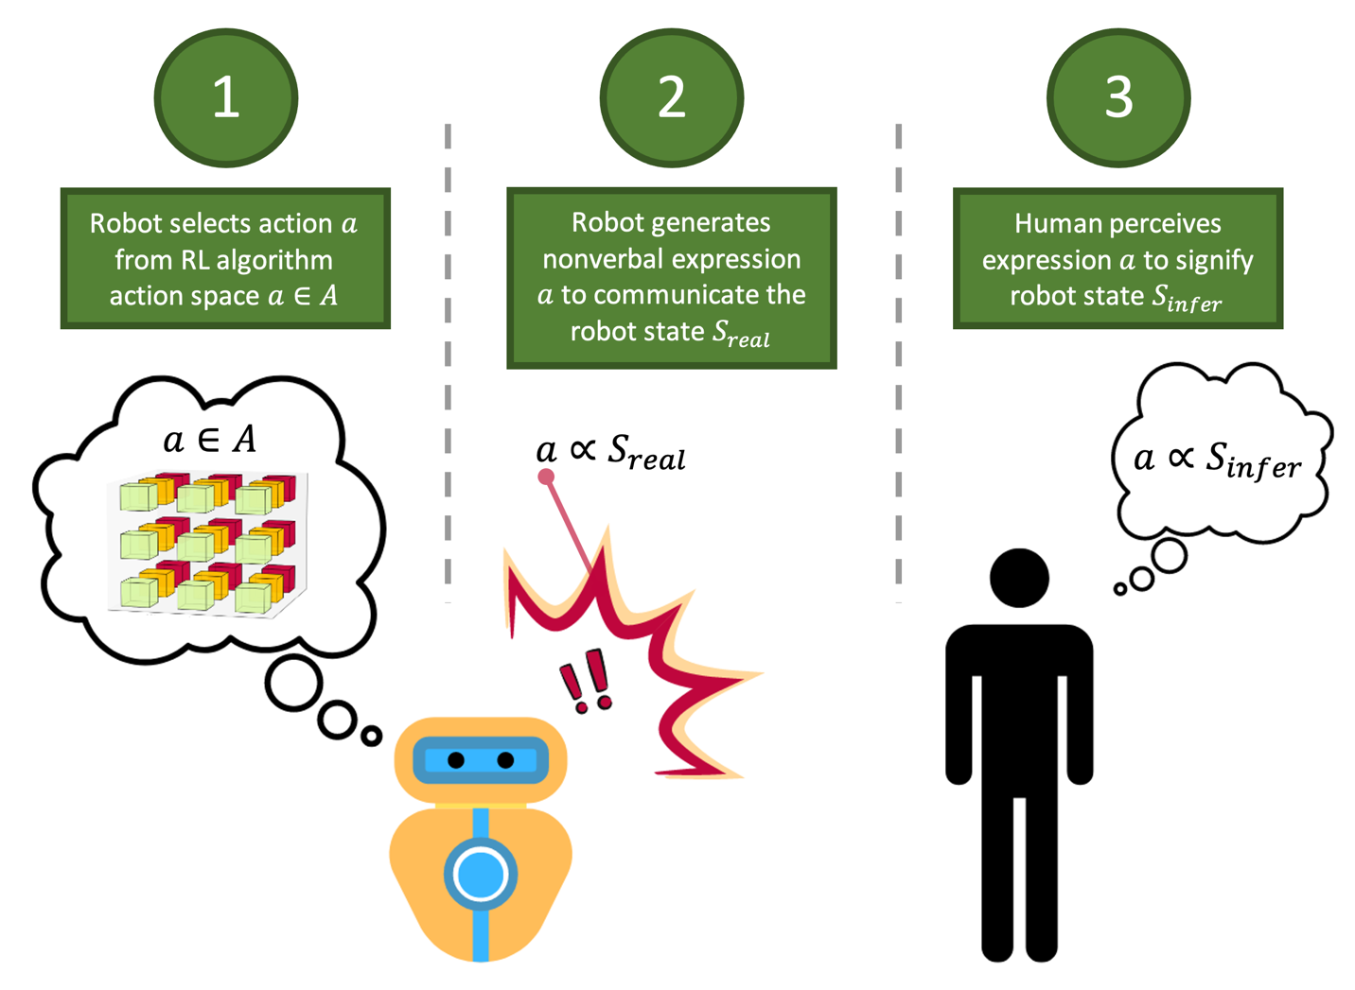

1

Robot selects action $a$ from RL algorithm action space $a∈A$

2

Robot generates nonverbal expression $a$ to communicate the robot state $S_{real}$

3

Robot selects action $a$ from RL algorithm action space $a∈A$

3

Robot selects action $a$ from RL algorithm action space

**­**